Pls contact us :35007117@ qq.com
-----------------------------------------------------------------------------------------
Tilt Module
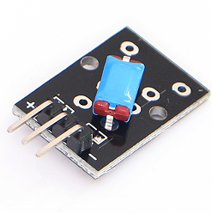
Features Working voltage: 3.3V~5V; digital switch output (0 & 1); High sensitivity

Tilt module can connect UNO R3 PIN13, make tilt remind test.
Pin 13’s LED，use tilt module connect Pin 3. When tilt module test there is button, led can be bright.

Code：
int Led=13;//Define LED interface
int buttonpin=3; //Define tilt switch sensor interface
int val;//Define numeric variable val
void setup()
{
pinMode(Led,OUTPUT);//Define LED as output interface
pinMode(buttonpin,INPUT);//Define the tilt switch sensor as the output interface
}
void loop()
{
val=digitalRead(buttonpin);//Read the value of the value of the digital interface 3 to val
if(val==HIGH)//When the tilt switch sensor detects a signal, the LED flashes
{
digitalWrite(Led,HIGH);
}
else
{
digitalWrite(Led,LOW);
}
}

